# OCT Duke Result

## VGG Model:

### Classification:

precision recall f1-score support

AMD 1.00 1.00 1.00 121

DME 1.00 0.99 0.99 155

NORMAL 0.99 1.00 1.00 209

accuracy 1.00 485

macro avg 1.00 1.00 1.00 485

weighted avg 1.00 1.00 1.00 485

### Accuracy and lost curve:

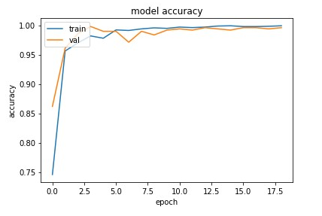

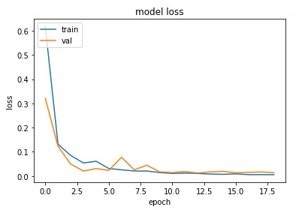

### Confusin matrix:

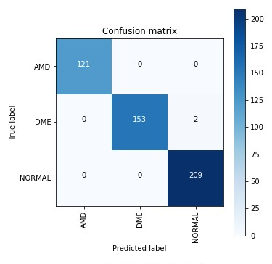

### ROC Curve:

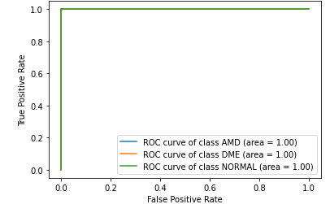

### Heat map:

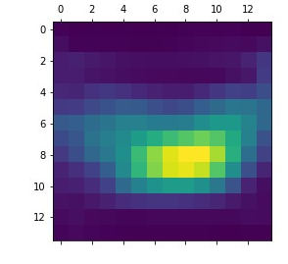

### Grandcam :

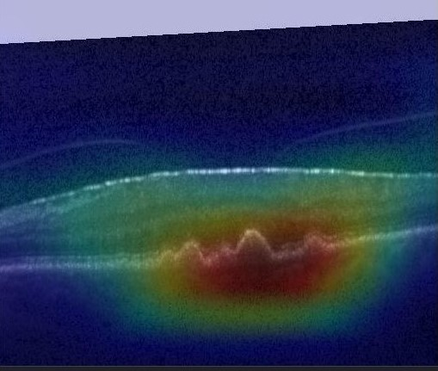

### Histogram:

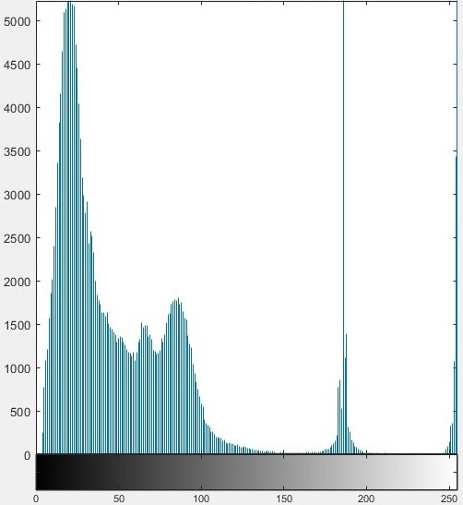

## Inception Resnet:

### Classification Result

precision recall f1-score support

AMD 1.00 1.00 1.00 121

DME 1.00 1.00 1.00 155

NORMAL 1.00 1.00 1.00 209

accuracy 1.00 485

macro avg 1.00 1.00 1.00 485

weighted avg 1.00 1.00 1.00 485

### Accuracy and lost curve:

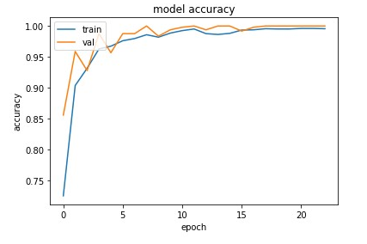

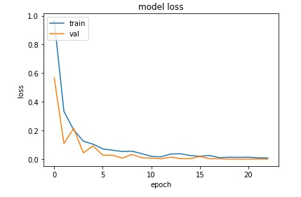

### Confusion matrix:

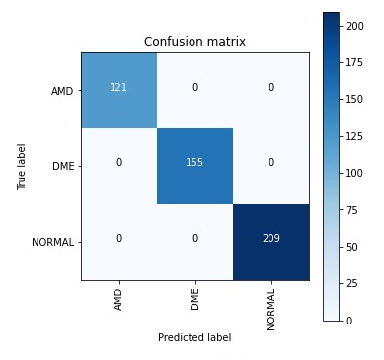

### ROC:

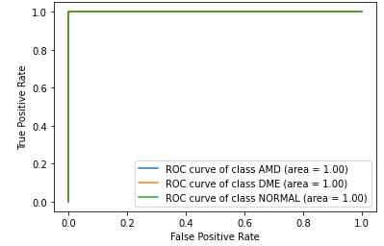

### Heatmap:

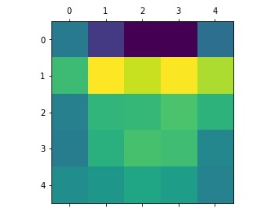

### Grandcam :

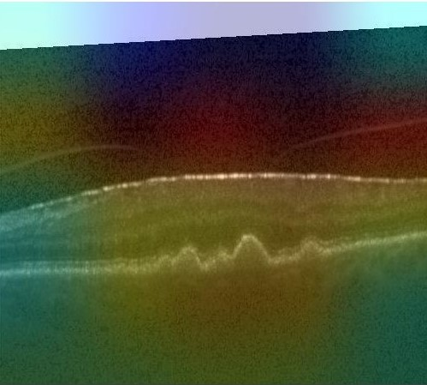

### Histogram:

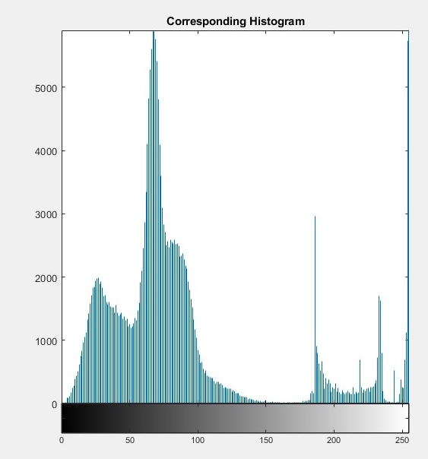

## Custom model:

### Classification model:

precision recall f1-score support

AMD 1.00 0.98 0.99 121

DME 0.99 0.96 0.97 161

NORMAL 0.97 1.00 0.99 203

accuracy 0.98 485

macro avg 0.99 0.98 0.98 485

weighted avg 0.98 0.98 0.98 485

### Accuracy and lost curve:

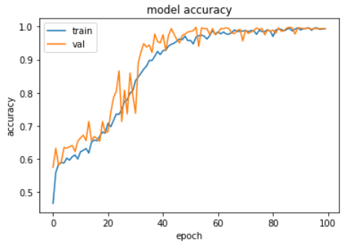

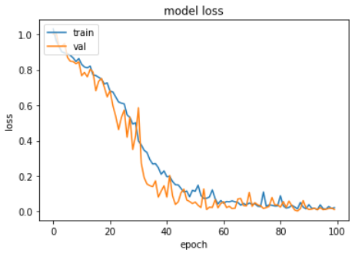

### Confusion Matrix:

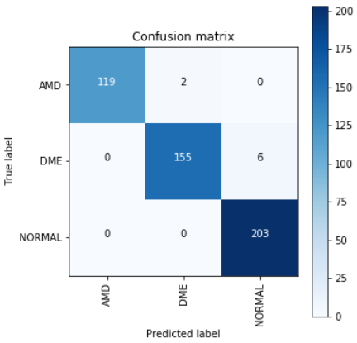

### ROC:

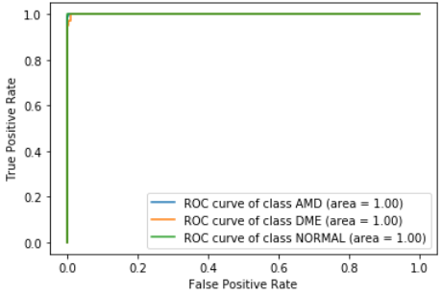

### Heat map

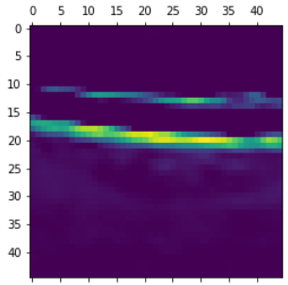

### Grandcam:

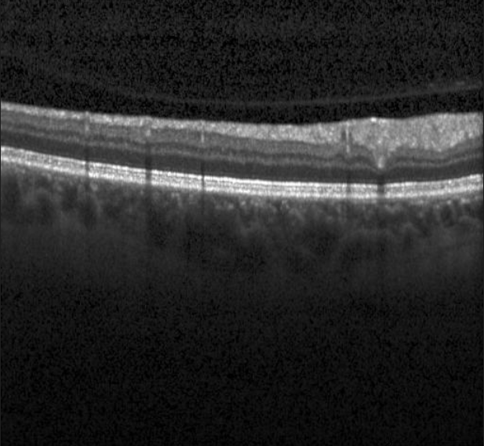

Histogram:

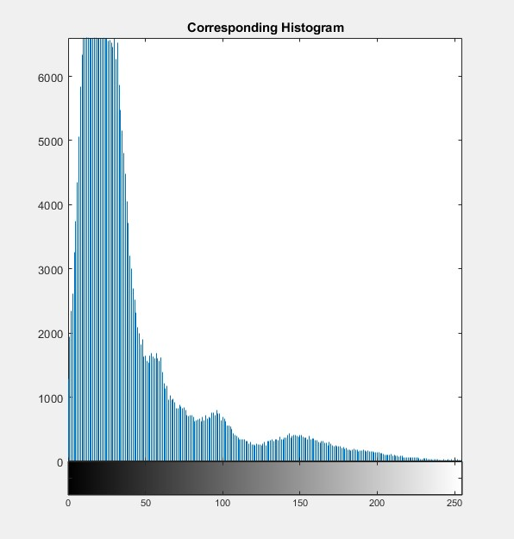

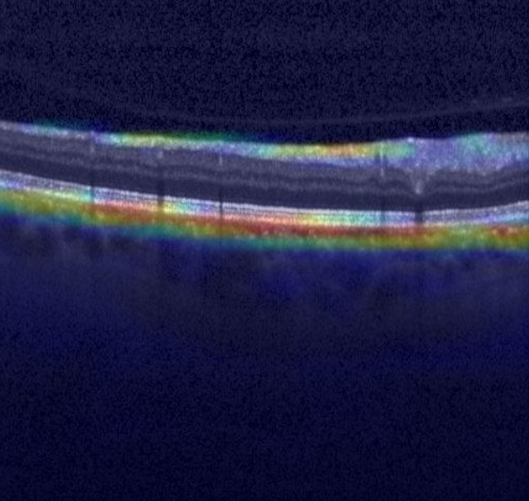

### Histogram:

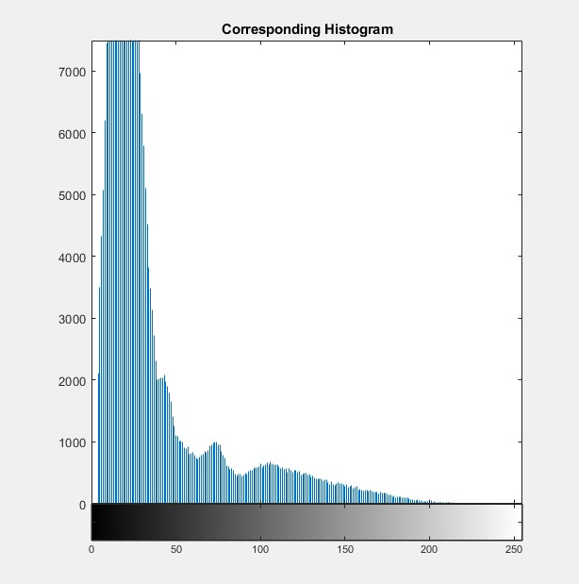

## Inception Model:

### Classification:

precision recall f1-score support

AMD 0.98 0.98 0.98 121

DME 0.99 0.95 0.97 155

NORMAL 0.97 1.00 0.98 209

accuracy 0.98 485

macro avg 0.98 0.98 0.98 485

weighted avg 0.98 0.98 0.98 485

### Accuracy and Loss curve:

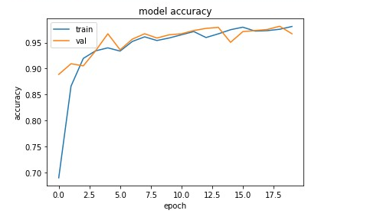

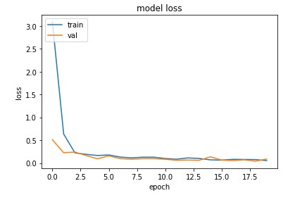

### Confusion Matrix:

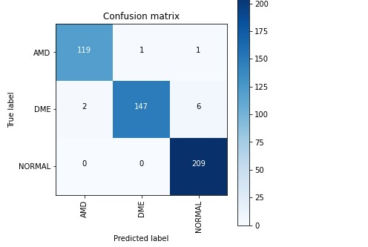

### ROC:

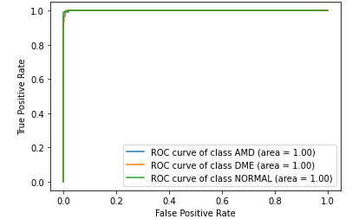

### Heatmap:

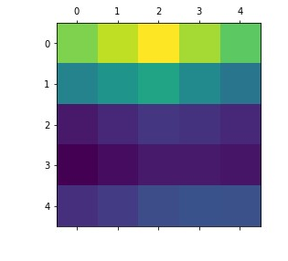

### Grandcam:

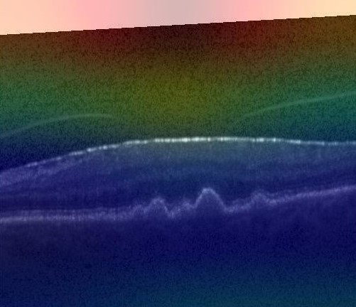

### Histogram:

